MINISTERIAL

ETHICS
AND
ETIQUETTE

“Building God’s People
on a Firm Foundation”

We put no stumbling block in anyone's path, so that our ministry will not be discredited. (2 Corinthians 6:3)

Whatever happens, conduct yourselves in a manner worthy of the gospel of Christ. (Philippians 1:27)

The Basis of Ministry

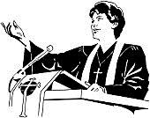
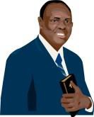
Ministry is based on three premises:

- A call from God. (Ex. 3:10- 12, Jer. 1:4-10, 17)

- A commitment to God. (Jn. 4:34, 1 Cor. 6:20)

- A commitment to serving and ministering to people. (Matt. 9:36)

Having theThe Right Attitude Towards Ministry


Matthew 20:21-29-

20: Then came to him the mother of Zebedee's children with her sons, worshipping him,
and desiring a certain thing of him.
21: And he said unto her, What wilt thou? She saith unto him, Grant that these my two sons may sit, the one on thy right hand, and the other on the left, in thy kingdom.
22: But Jesus answered and said, Ye know not what ye ask. Are ye able to drink of the cup that I shall drink of, and to be baptized with the baptism that I am baptized with? They say unto him, We are able.
23: And he saith unto them, Ye shall drink indeed of my cup, and be baptized with the baptism that I am baptized with: but to sit on my right hand, and on my left, is not mine to give, but it shall be given to them for whom it is prepared of my Father.
24: And when the ten heard it, they were moved with indignation against the two brethren. 25: But Jesus called them unto him, and said, Ye know that the princes of the Gentiles
exercise dominion over them, and they that are great exercise authority upon them.
26: But it shall not be so among you: but whosoever will be great among you, let him be
your minister;
27: And whosoever will be chief among you, let him be your servant:
28: Even as the Son of man came not to be ministered unto, but to minister, and to give his life a ransom for many.
29: And as they departed from Jericho, a great multitude followed him.
Minister (Strong’s # 1247 Gr.) diakŏnia, dee-ak-on-ee´-ah; attendance (as a servant, etc.); aid (official), minister (-ing, - tration, , -try), office, relief, service (-ing). diakŏnŏs, to run on errands; an attendant,
i.e. a waiter (at table or in other menial duties); spec. a Christian teacher and pastor (tech. A deacon or deaconess)- deacon, minister, servant.


Church Myths Concerning Ministry
Myth #1: One must have a “title” in order to have ministry.
The Truth: There are no titles in the church, but functions. Although God does call certain ones to occupy leadership positions in the church (ie.


Apostles, Prophets, Evangelists, Pastors and Teachers) what one does in the church does not indicate that one is entitled to a place of superiority or importance over his brothers and sisters, but rather, is given greater responsibility. (Luke 12:47- 48, James 3:1)

Church Myths Concerning Ministry

Myth #2: Those who occupy the pulpit are somehow higher, better, or more spiritual than others.

The Truth: The pulpit is not a place of exaltation, but of service. God has placed us there to see (to) the needs of His people. (1 Peter 5:1-4)
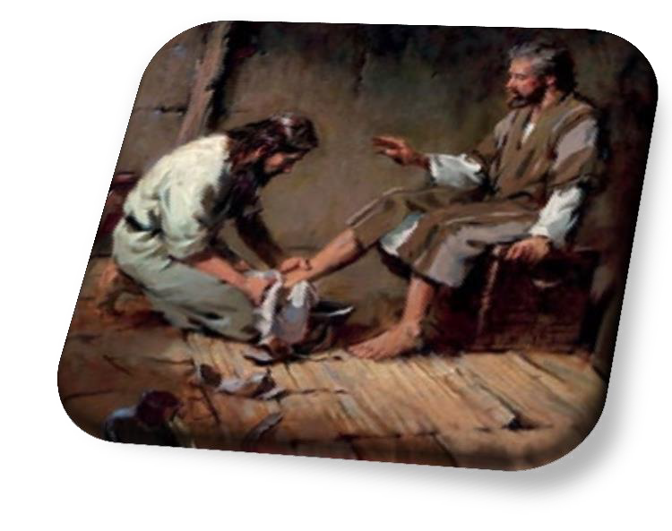

Church Myths Concerning Ministry
Myth #3: It is wrong to aspire to leadership in the church.
The Truth: It is biblically acceptable to aspire to a position of leadership in the church.
1Timothy 3:1- “This is a true saying, If a man desire the office of a bishop, he desireth a good work.”
Bishop (1 Tim. 3 1-7) (Strong’s # 1984(5) Gr.) ĕpiskŏpŏs, overseer.

However, the following conditions must be met...


Motives for Ministry


- Our reasons for aspiring to a ministry position must be Godly ones. We must desire God’s will above our own. (Matt. 26:42)

- We must be willing to submit to Godly church leadership, and endure God’s building process to enable us to carry the anointing (gifts + Christlike character = power) that He has placed on our lives. (1Tim. 3:6)
- We must be sure that God has called us to a place of leadership in the church. It is dangerous and presumptuous to attempt to step into a ministry office that God has not called us to. (Heb. 5:4)
1 Peter 5:1-4
1: The elders which are among you I exhort, who am also an elder, and a witness of the sufferings of Christ, and also a partaker of the glory that shall be revealed:


2: Feed the flock of God which is among you, taking the oversight thereof, not by constraint, but willingly; not for filthy lucre, but of a ready mind;
3: Neither as being lords over God's heritage, but being ensamples to the flock.
4: And when the chief Shepherd shall appear, ye shall receive a crown of
glory that fadeth not away.
Ministers Are to Set the Example

1 Timothy 4:12-15-
12: Let no man despise thy youth; but be thou an example of the believers, in word, in conversation, in charity, in spirit, in faith, in purity.


13: Till I come, give attendance to reading, to exhortation, to doctrine.
14: Neglect not the gift that is in thee, which was given thee by prophecy, with the laying on of the hands of the presbytery.
15: Meditate upon these things; give thyself wholly to
them; that thy profiting may appear to all.

1 Peter 5:2-3-
2: Feed the flock of God which is among you, taking the oversight thereof, not by constraint, but willingly; not for filthy lucre, but of a ready mind;

3: Neither as being lords over God's heritage, but
being ensamples to the flock.
*So a minister must therefore be a servant.*

What is Ethics?
ETHICS- having to do with right and wrong. Good behavior and conduct.

ethics, n. 1. A system of moral principles. 2. The branch of philosophy dealing with right and wrong and the morality of motives and
ends. (Random
House Webster’s Dictionary)

The Basis of Ethics:

- Christian ethics is based on the knowledge of God. Without the love of God, true ethical behavior is impossible.
- Ethical behavior cannot be imposed (forced) on us. It must come from within.
- In 2 Peter 1:5, the bible would call it Virtue. It is something that you add to your life. It is the quality to do what is right. It is an understanding that your life functions in relationship to others

Starting Points for All Ethical Behavior:
- We should learn to look over the mistakes of others as we would have them to do ours.


- Relationships between ministers must be sound.
- There is a direct relationship between the life of the minister and his or her relationships with other ministers, laity, and even unbelievers.
Therefore…


The starting point • for ministerial ethics is found in being BORN AGAIN.


John 3:3: "I assure you and most solemnly say to you, unless a person is born again [reborn from above—spiritually transformed, renewed, sanctified], he cannot [ever] see and experience the kingdom of God".
Ministers, like other professionals, are grouped together in the eyes of the public.



Ministers Must…
  - Respect the ministries (and pulpits) of others.


  - Not Lie(Colossians 3:9; Proverbs 12:22)
  - Not Gossip
  - Stay out of the internal affairs of other churches.
  - Never perceive

another minister as a threat to one’s a

“Can two walk together, except they be agreed?”
-Amos:3:3

Brother-and sister-liness, respect, and professional courtesy means that ministers do not discuss other ministers and their families with members.

Ministers Must Have…

• Integrity: Ministers must uphold honesty, sincerity, and moral uprightness in all their lives and ministries, following Jesus Christ’s example of speaking and acting with integrity (Matthew 5:37, James 5:12).
• Servant Leadership: Ministers are called to serve rather than be served, demonstrating humility, compassion, and selflessness in their relationships with others (Matthew 20:26-28, Mark 10:45).
• Love and Compassion: Ministers are called on to show love, empathy, and compassion to everyone, fulfilling the charge to love one another as Jesus loved us (John 13:34-35, 1 John 4:7-8).

- Accountability: Ministers acknowledge the value of responsibility, humility, and openness in their leadership and are answerable to God, their religious community, and themselves for their deeds and choices (Hebrews 13:17, James 3:1).
- Truthfulness: Ministers are called to communicate the truth in love, avoiding lying and deception while adhering to the standards of honesty and integrity (Ephesians 4:25, Colossians 3:9).
- Ethical Conduct: Ministers are obligated to live according to Scripture’s moral teachings, which include concepts such as fairness, justice, and regard for the dignity of all people (Micah 6:8, Galatians 6:10).
- Stewardship: Ministers must acknowledge their responsibility as stewards of God‘s gifts and blessings and appropriately handle the resources and duties given to them (1 Peter 4:10, Luke 16:10–12).

What is Etiquette?

Etiquette- socially correct behavior and good manners.
et-i-quette n. conventional requirements for proper social or professional behavior. (Random House Webster’s Dictionary)
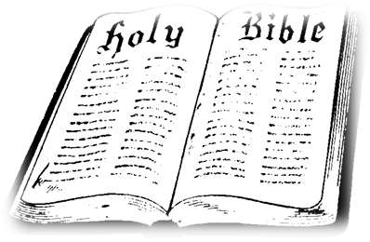

Ethics and Etiquette- What’s the Difference?


ETHICS ETIQUETTE

OUTSIDE

INSIDE

THE MINISTER

Ethics speaks to the inward condition, while Etiquette deals with outward behavior.

Examples of Unethical Behavior

- Lying
- Plagiarism
- Misuse of Church
Funds/ Property
- Improper Relationships With Members/ Fellow Ministers
- Hostility/ Indifference towards Fellow
Ministers
THE MINISTER
- Involvement in Other Churches’ Affairs

Etiquette and Ministry









- Like the military officer, the minister must never find him/ herself guilty of “conduct unbecoming an officer and a gentleman.” (see 1 Tim. 3:1-7)
- The minister must never forget that he or she must be on guard against every temptation that could come up against him or her.
- Many ministers have lost their ministries because of the “Death Trap.”

What is “The Death Trap?”




  - Prayerlessness
  - Money
  - Pride
  - Sex

“Wherefore let him that thinketh he standeth take heed lest he fall.”-1Cor:10:12
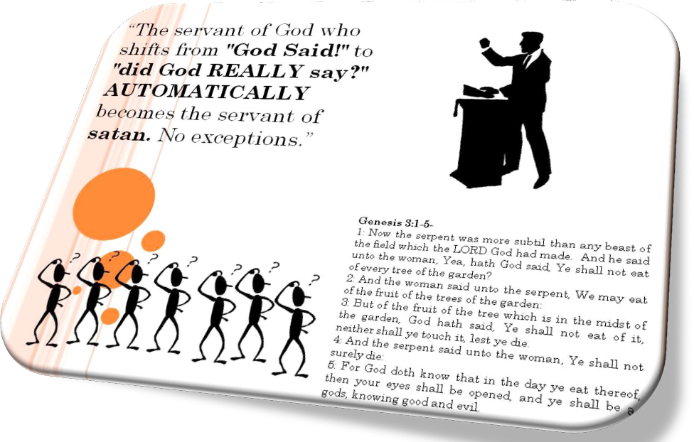


Professional Courtesy in the Pulpit
- The pulpit should never be used as a battleground, or to correct the behavior of any one individual. (see 2 Tim. 2:24-25)
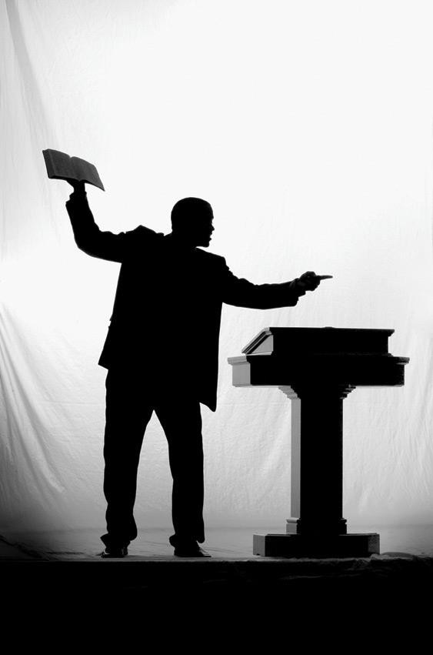

- It is considered a general courtesy for preachers to listen to other preachers when they speak.

- Plagiarism (taking and using another person’s material) is a no-no. It is another word for STEALING. One should at least make mention of the source of the information.

- When one is asked to participate in a service (i.e. read scripture, pray, preach, sing) one should stand up, do EXACTLY WHAT THEY ARE ASKED TO DO, and
SIT DOWN. God is not the author of confusion. The spirit of the prophet is subject to the prophet. You CAN help it! (see 1 Cor. 14:32-33)

Dress Code For Ministers:

- There is no one-size-fits-all dress code for what to wear in the pulpit. Preachers/Ministers may wear a variety of clothing, from jeans and sneakers to tailored suits. However, some things to consider when choosing what to wear include:
- Role and responsibility: What you wear can communicate your role and responsibility. For example, you might expect a surgeon to wear scrubs, and a police officer to wear a uniform.

- Intention: Consider what message you want to send, and who you are dressing for.
- Biblical guidance: The Bible doesn't provide a dress code for church, but 1 Timothy 2:8-10 does address how women should dress modestly and with self-control.

- Ministers, both men and women should dress is appropriate clothing that is not revealing and/or too form fitting.
- No minister is to wear a sleeveless or thin strap tops/blouses or shirts while ministering
inside of a church.
- When conducting street ministry, the minister should dress appropriately for the weather.

- Please be aware that you should not be distracting to others. The point is Jesus!

Honor:

Honor in the Bible typically has a communal, even public, meaning. In other words,
honor is something that is recognized or bestowed by the community.

Gamaliel, for instance, was “held in honor by all the people” (Acts 5:34).

In the Old Testament book of Esther, the honor shown to Mordecai was very public,
much to Haman’s disgrace (Est. 6).

Proverbs tells us that the wise and the righteous will receive honor (Prov. 3:35; 11:16)
but that honor is not fitting for a fool (26:1).

- The Bible commands people to honor many people and things, including:
- God: Psalm 22:23
- Parents: Exodus 20:12
- Those in authority: Romans 13:1-7
- The elderly: Leviticus 19:32
- Church leaders: 1 Timothy 5:17
- Others who serve Christ faithfully
- Certain God-ordained institutions, such as the Sabbath day and marriage

The Bible also commands Christians to “honor everyone” (1 Peter 2:17) and to “outdo one
another in showing honor” (Rom. 12:10).

All human beings are made in God’s image and are worthy of honor. As the psalmist
writes, God has crowned humanity “with glory and honor” (Ps. 8:5).

Significantly, Peter exhorts us, “Honor the emperor” (1 Peter 2:17), at a time when
believers were being persecuted for the faith. Honor is not tied to our feelings for
someone. It is honoring the person because God commands it.

Protocols:

- When ministering, be sure to verbally acknowledge and express honor to the
senior leaders, host and other leaders present.

“This may look like…I want to thank and honor Pastor Suchy-muchy for bringing me. I want to acknowledge all of the 5 fold, ministers and everyone.”

- Be sure to stay on the assigned topic given.
This is not the time to preach a different message or another revelation unless given specific instructions from Holy Spirit.

- Be sure to minister within the allotted time frame provided.
If there is not a time frame given, the average message is between 35-45mins long.

Work Cited:

Ministerial Ethics & Etiquette: Christ Foundation Ministries, Inc. Rochester, NY

https://tabletalkmagazine.com/article/2019/02/what-is-honor/

